ASSESSMENT 4

*“INTRODUCTION TO PYTHON”*

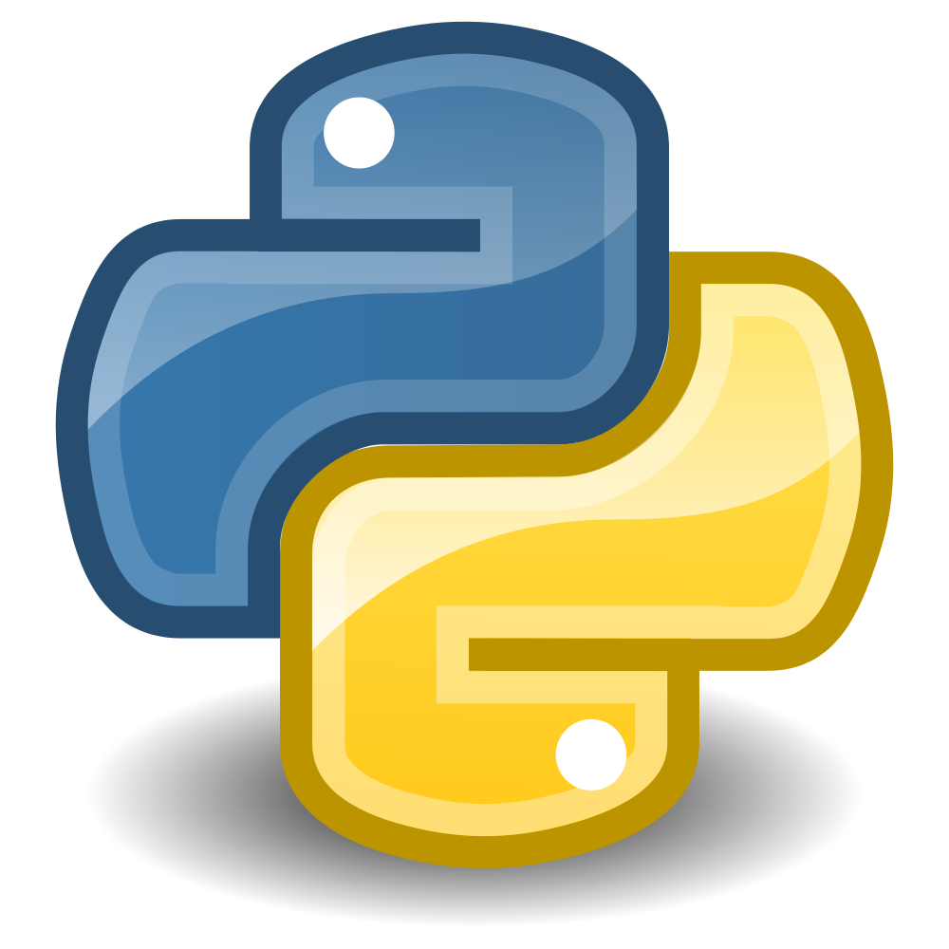

Submitted By

VAIBHAV PATIDAR

IPS ACADEMY, INDORE (M.P.)

**Date :** 12-12-2023

**Week 2** | **Day - 02**

**Introduction to Python :**

* It is Guido van Rossum in 1991.
* It is High-Level language.
* Python has more enhanced code readability.
* It is most popular language according to IEEE survey.

**Why to learn Python :**

* It is easy to learn
* It is free and open source.
* Python has vast implementations :

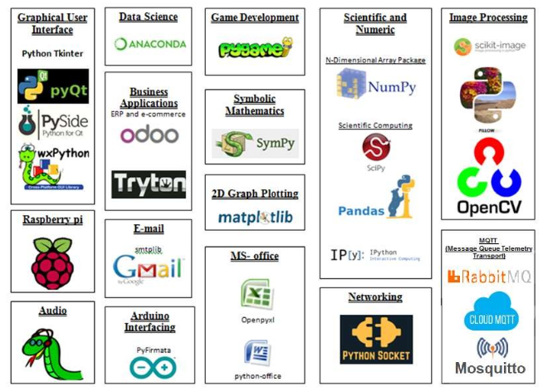

* Python is also used for webs development :

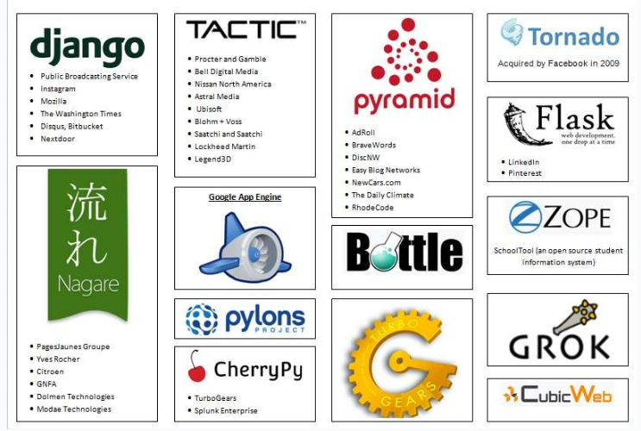

* Python is used many other fields also :

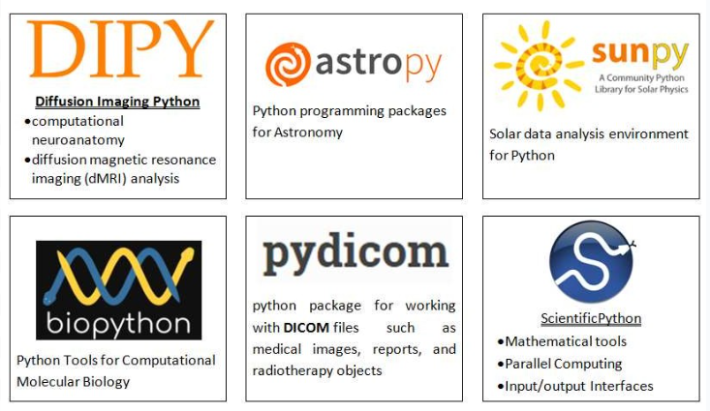

**Hello World in Python :**

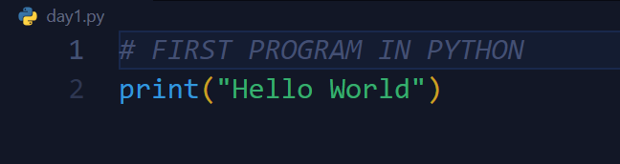

**Escape Sequence in Python :**

* There are some special characters which can be used only with a ( / ), and these are known as escape sequence.
* Ex →

| **Escape Sequence** | **Working** |
| --- | --- |
| \\ | Backslash (\) |
| \' | Single quote (') |
| \" | Double quote (") |
| \n | ASCII Linefeed (LF) |
| \t | ASCII Horizontal Tab (TAB) |

* **CODE →**

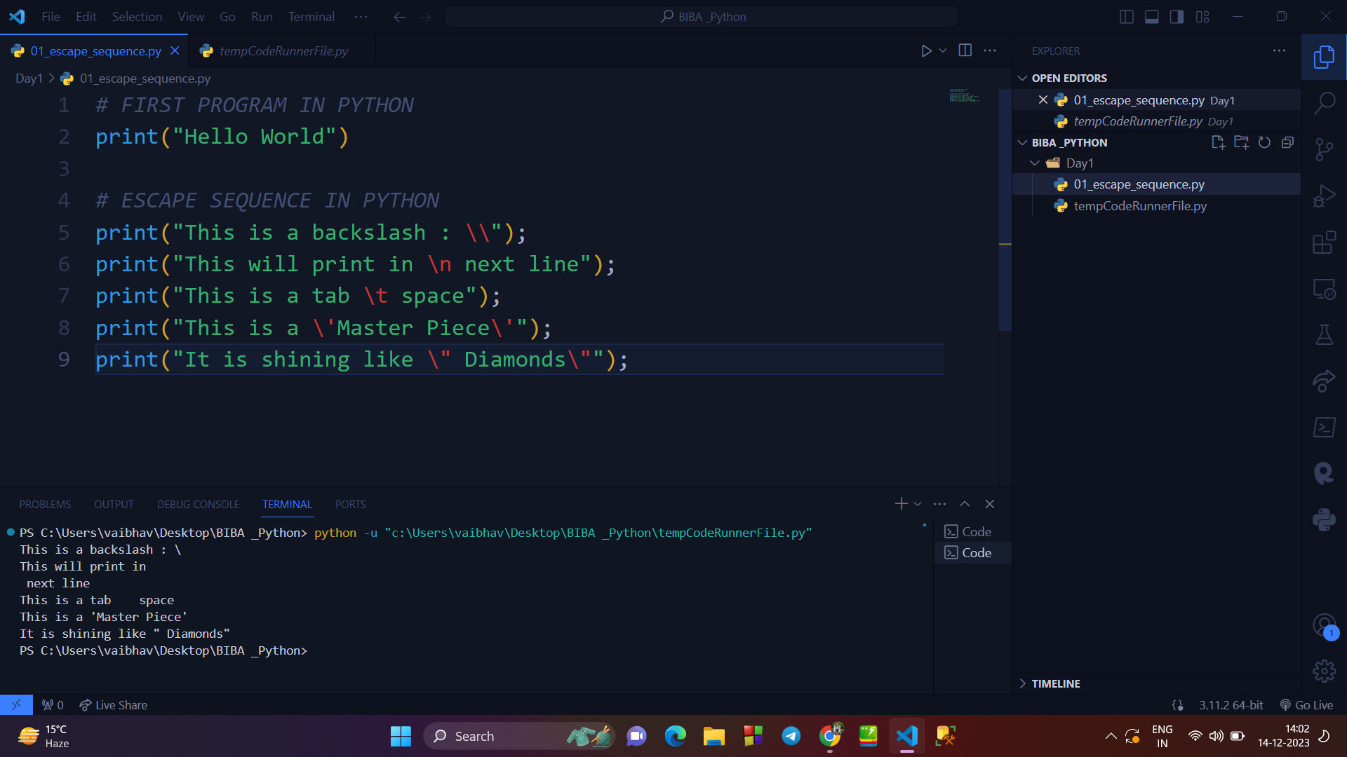

**Python has five standard data types :**

* Numbers(Integer and Float)
* String
* List (Array)
* Tuple (Constant Array)
* Dictionary

**Variable Number type :**

* Integer (whole number)
* Float (decimal point number)
* Character/String (ASCII format)
* Boolean (True and False)

**→ Checking Type of variable :**

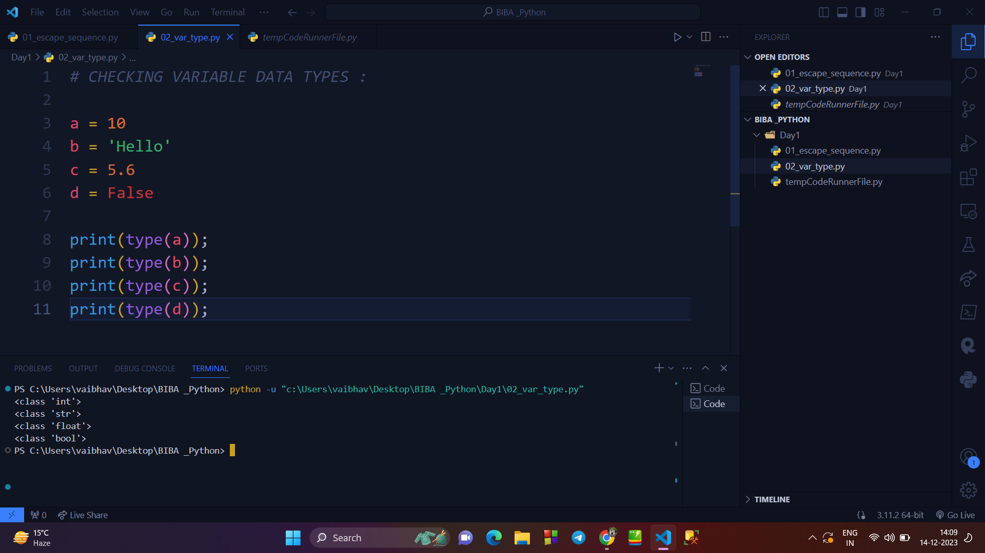

**→ Taking input through INPUT() :**

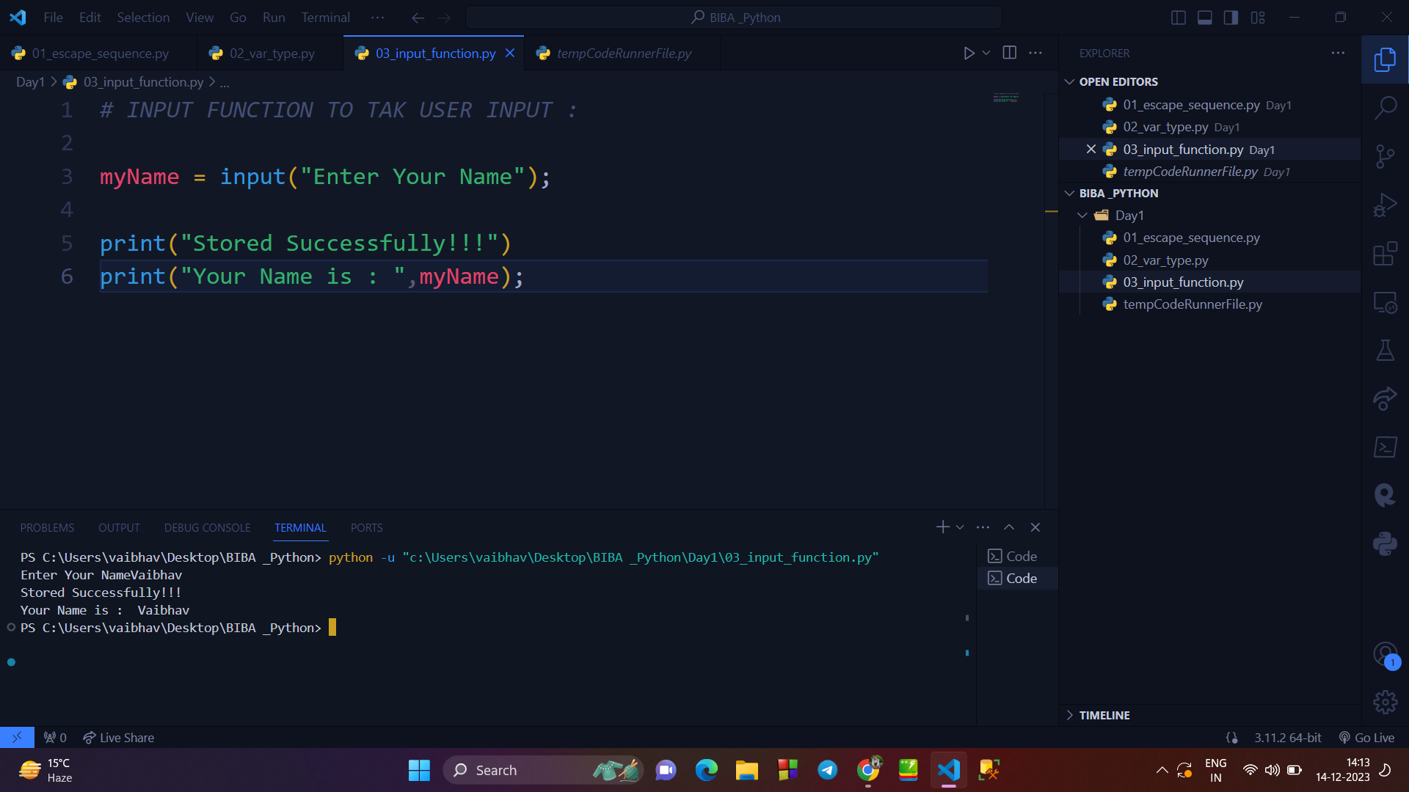

**→ Why Python?**

* Simple
* Easy to Learn
* Free and Open Source
* High-level
* Dynamically Typed
* Portable/Platform Independent/Cross Platform
* OS
* Interpreted
* Multiparadigm
* Extensible
* Extensive Libraries
* Text Processing Modules
* Data Types
* Garbage Collection